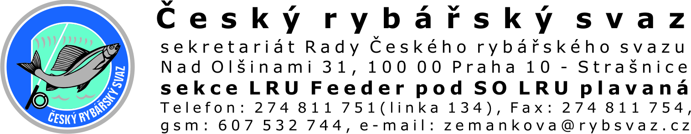

Team Registration for Czech National Championship in Feeder 2012
Manager: František Pelíšek, mobile: +420 606 656 905, e-mail:f.pelisek@tiscali.cz
English speaking participants – please contact Vera Papirnikova, mobile: +420 602 556 259, e-mail: vera.papirnikova@daiwa-cormoran.com

Team name (in case of national representation team from different country than Czech Republic please note this fact)
List of team members:
No. | Reg.No. | Last and First Name of the participant | Nationality
1.
2.
3.
Team Captain:
Phone:
E-mail:

Team must be formed by registered participants only and they will be included into the team competition after all members will pay the registration fee.

Filled registration form please sends as soon as possible to: f.pelisek@tiscali.cz Deadline is 30.6.2012 (the competing spaces are limited to maximum 140 participants, if there will be no availability for you to compete we will inform you by e-mail).

By sending this form you confirm, that you have acknowledged the Czech Fishing Law and Fishing Competing rules of the Czech Fishing Association for 2012 and that you will obey those rules and laws.
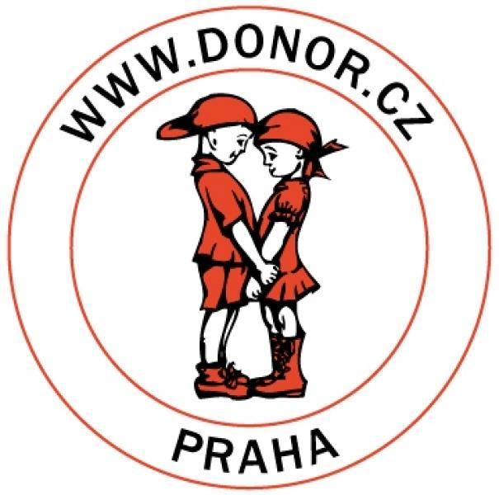
Záznamy pořadatele: (please do not fill out – for management purposes)

Přihláška přišla dne:

„Nothing in the world belongs to us, only time. “
Confucius, 551 p.m.

