
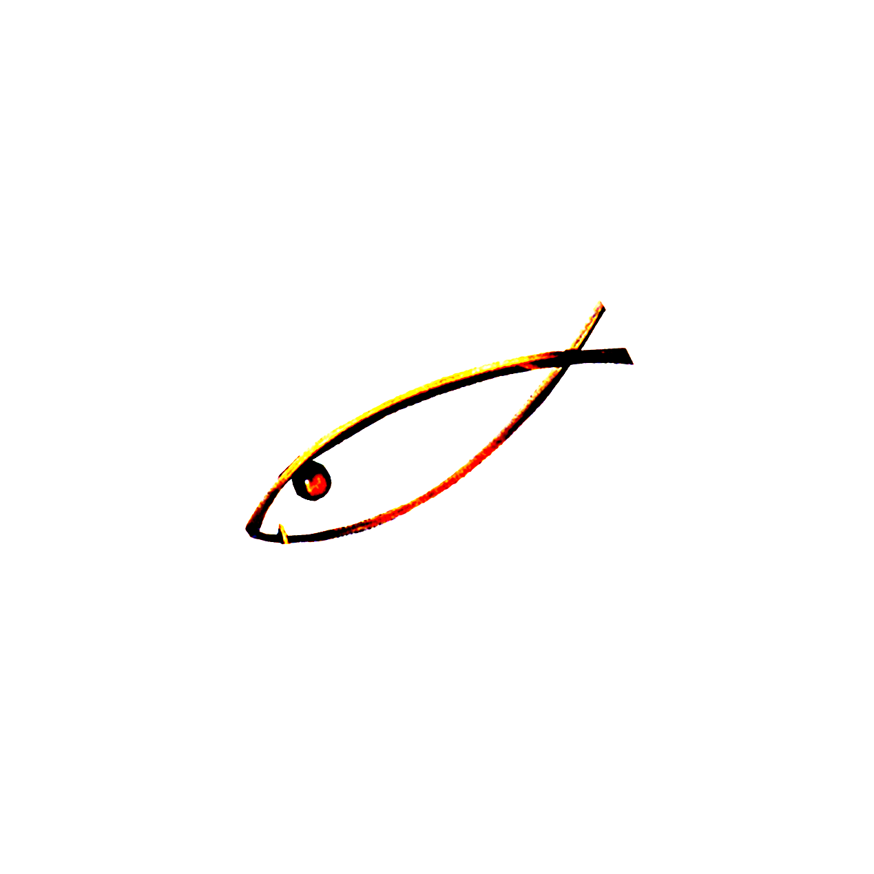

FIPSed
FIPSed
F ÉDÉRATION INTERNATIONALE
DE LA P ÊCHE SPORTIVE EN EAU DOUCE

WORLD & EUROPEAN CHAMPIONSHIPS

CHAMPIONSHIPS | 2014 | 2015 | 2016 | 2017 | 2018 | 2019
ICE FISHING | BELARUS  22-23 FEBRUARY MINSK | FINLAND | UKRAINE | BULGARIA
CARNIVOROUS A.B.  SHORE | BULGARIA  17-18 MAY  ASENOVGRAD | IRELAND | SLOVAKIA
CLUBS | SLOVENIA  7-8 JUNE  RADECE | SLOVAKIA | SAN MARINO
EUROPE | BELGIUM  28-29 JUNE  BERNISSART | BELARUS | NETHERLAND | PORTUGAL  IRELAND  ITALY
VETERANS | ITALY  8-9 AUGUST  ROME | PORTUGAL | CZECH REPUBLIC | ENGLAND  BELGIUM
DISABLED | ITALY  8-9 AUGUST  ROME | PORTUGAL | CZECH REPUBLIC | ENGLAND  BELGIUM
YOUTH  U14 - U18 - U23 | NETHERLAND  25-26 JULY  ASSEN | SERBIA | PORTUGAL | IRELAND
LADIES | PORTUGAL  23-24 AUGUST  CORUCHE | BELGIUM | SPAIN | POLAND  ENGLAND
NATIONS | CROATIE  13-14 SEPTEMBER  SVETA MARIJA | SLOVENIA | BULGARIA | SPAIN  BELGIUM |  | UKRAINE
TROUT WITH NATURAL BAITS | ANDORRA  27-28 SEPTEMBER  SANT JULIA  DE LORIA | FRANCE
CARNIVOROUS A.B.  BOATS | TO BE DEFINED | EGYPT | ENGLAND
BLACK-BASS | MEXICO  7-8-9 NOVEMBER  PRESA EL CUCHILLO - CHINA | ITALY | PORTUGAL  SOUTH AFRICA
CARP | TO BE DEFINED  15-16-17-18 OCTOBER | SPAIN | BOSNIA |  | UKRAINE
FEEDER | IRELAND  19-20 JULY  COACHFORD | NETHERLAND | SERBIA | UKRAINE
CHAMPIONSHIPS ASSIGNED AFTER VENUES INSPECTIONS: Nations quoted in bold and underlined
CANDIDATURES TAKEN INTO CONSIDERATION: Nations quoted in italic, in bold and underlined (still pending for the definitive allocation)
CANDIDATURES TO BE CONFIRMED: Nations without underline and bold font.
Updated on 02/12/2013

