WORLD & EUROPEAN CHAMPIONSHIPS

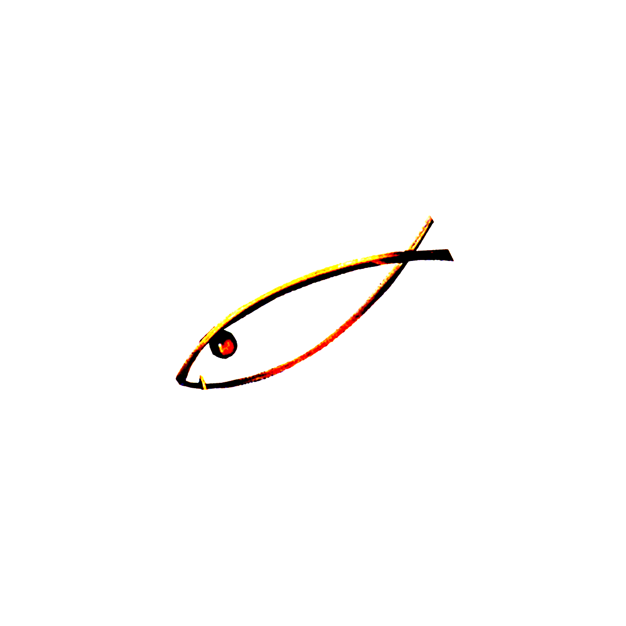
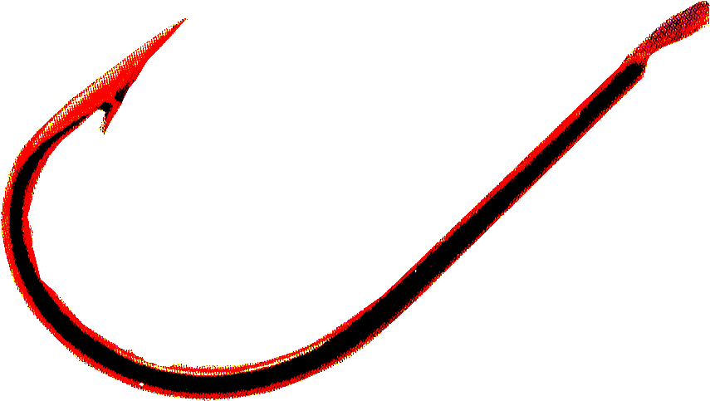
FIPSed
FIPSed
F ÉDÉRATION INTERNATIONALE
DE LA P ÊCHE SPORTIVE EN EAU DOUCE

CHAMPIONSHIPS | 2015 | 2016 | 2017 | 2018 | 2019 | 2020
ICE FISHING | 12th FINLAND  28-29 March  Kuopio | UKRAINE | BULGARIA
CARNIVOROUS A.B.  SHORE | 13th IRELAND  23-24 May  Craigavon | SLOVAKIA
CLUBS | 35th SLOVAKIA  25-26 July  Žilina | SAN MARINO |  | IRELAND | IRELAND
EUROPE | 21ST BELARUS  27-28 June  Zaslavl | NETHERLAND | PORTUGAL  IRELAND  ITALY
VETERANS | 8th PORTUGAL  5-6 June  Cabeção | CZECH REPUBLIC | ENGLAND  BELGIUM
DISABLED | 17th PORTUGAL  5-6 June  Cabeção | CZECH REPUBLIC | ENGLAND  BELGIUM
YOUTH  U14 - U18 - U23 | SERBIA  8^{h} U14  20th U18  29th U23  7-8 August  Smederevo | PORTUGAL | IRELAND
LADIES | 22ND BELGIUM  22-23 August  Charleroi Canal | SPAIN | POLAND  ENGLAND
NATIONS | 62ND SLOVENIA  12-13 September  Radeče | BULGARIA | SPAIN  BELGIUM |  | UKRAINE
TROUT WITH NATURAL BAITS | BULGARIA  4TH CLUB  23RD NATION  25-26 September  Asenovgrad | ITALY
CARNIVOROUS A.B.  BOATS | 8th ESTONIA  25-26 September  Kuldkala |  | ENGLAND
BLACK-BASS | 11th ITALY  23-24-25 October  Bolsena | PORTUGAL
CARP | 17th SPAIN  Date to be defined October  Caspe | BOSNIA | CROATIA  HUNGARY | UKRAINE
FEEDER | 5th NETHERLANDS  11-12 July  Westdorpe | SERBIA | UKRAINE  SPAIN
CHAMPIONSHIPS ASSIGNED AFTER VENUES INSPECTIONS: Nations quoted in bold and underlined
CANDIDATURES TAKEN INTO CONSIDERATION: Nations quoted in italic, in bold and underlined (still pending for the definitive allocation)
CANDIDATURES TO BE CONFIRMED: Nations without underline and bold font.

